**Jobs**

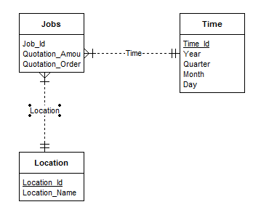

**Invoice**

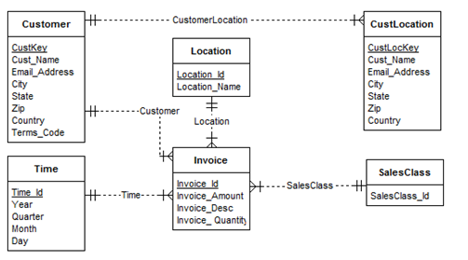

**Leads2Jobs**

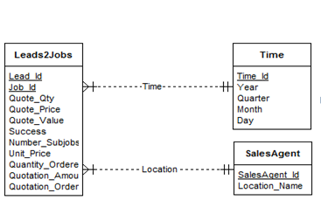

**Jobs2SubJobs2Shipments**

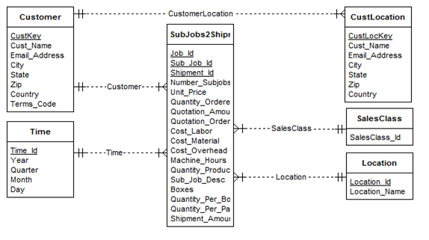

**Sales2Costs**

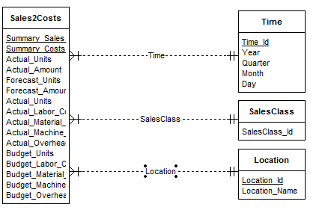

|  |  |  |  |
| --- | --- | --- | --- |
| **Schema type** | **Dimension tables** | **Fact table** | **Comments** |
| Constellation | Time  Location  SalesAgent  SalesClass  Customer | Jobs  Leads2Jobs  Invoice  Jobs2SubJobs2Shipments  Sales2Costs | -  -  -  -  - |